ICT1301 – Lab 5: E-mail Cryptography

Task A: Step-by-Step Instructions
Step 1: Download and Install Mozilla Thunderbird
- Go to Mozilla Thunderbird.
- Click the Download button and run the installer.
- Follow the on-screen prompts to install Thunderbird, including clicking Yes for User Account Control and Next for the installation steps.
- Once installed, check Launch Mozilla Thunderbird, and click Finish.
Step 2: Configure Your Gmail Account with Thunderbird
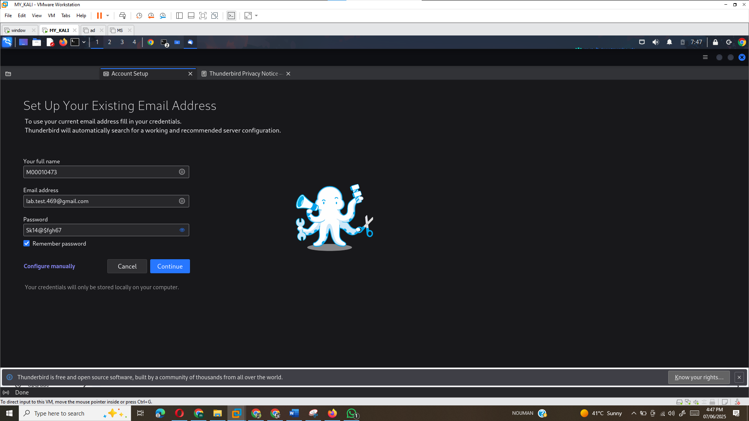
Step 2: Configure Your Gmail Account with Thunderbird
- In Thunderbird, you will be prompted to enter your name, email address (your Gmail address), and password.
- Uncheck the Remember Password box, and click Continue.
- If you have 2-Step Verification enabled on your Gmail account, you will be prompted for your password and verification code. Enter those and click Allow.
- Once logged in, go to your Inbox in Thunderbird.
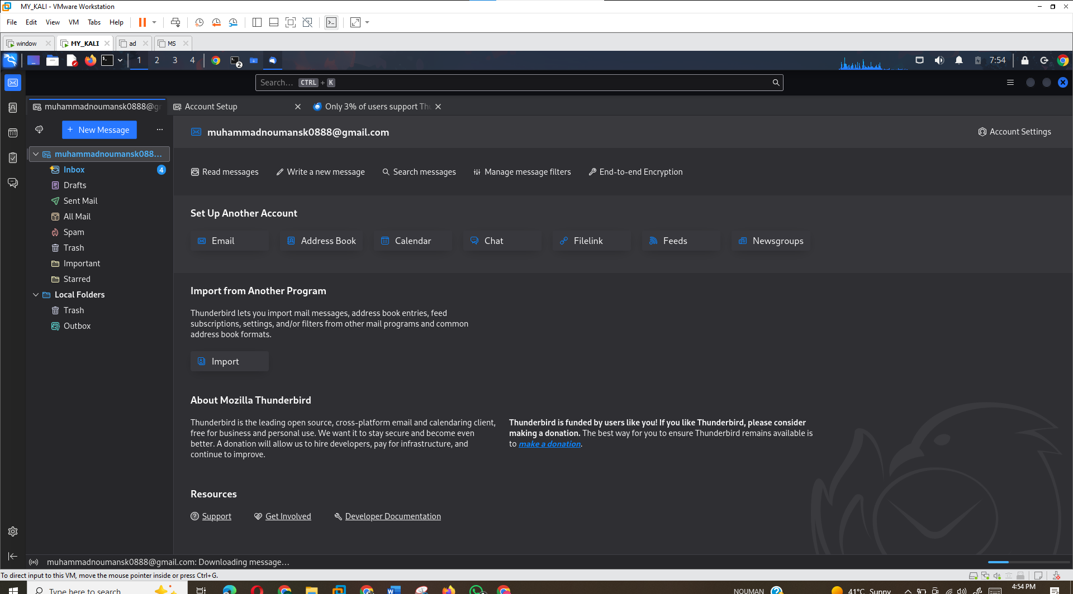
Step 3: Configure Your Public/Private Key Pair for Encryption
- In Thunderbird, go to Account Settings.
- Under your email address, click on End-to-End Encryption.
- In the OpenPGP section, click Add Key.
- Select Create a New OpenPGP Key and click Continue.
- Keep the default selections and click Generate Key.
- After generating the key, click Confirm.
- Once created, click on the Key Properties button and explore the Your Acceptance, Certifications, and Structure tabs.
- If needed, change the expiration date (though you can cancel and leave it as default).
- Ensure Disable Encryption for new messages is selected, and Sign unencrypted messages is unchecked.
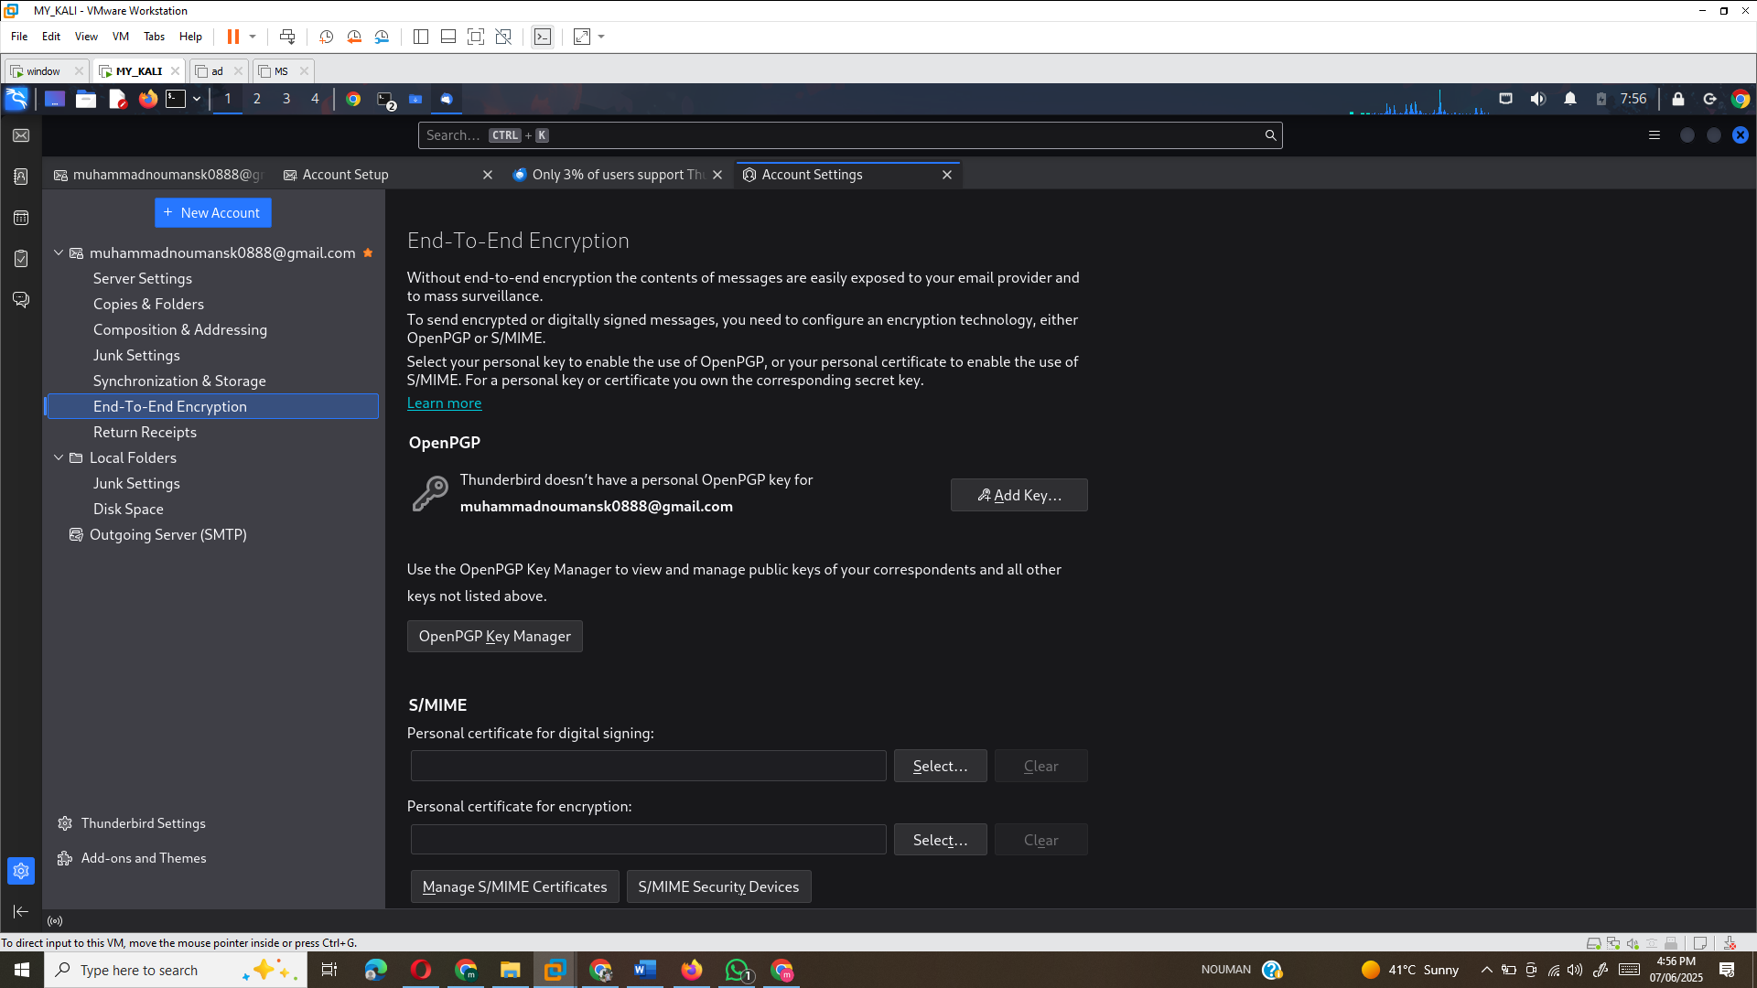
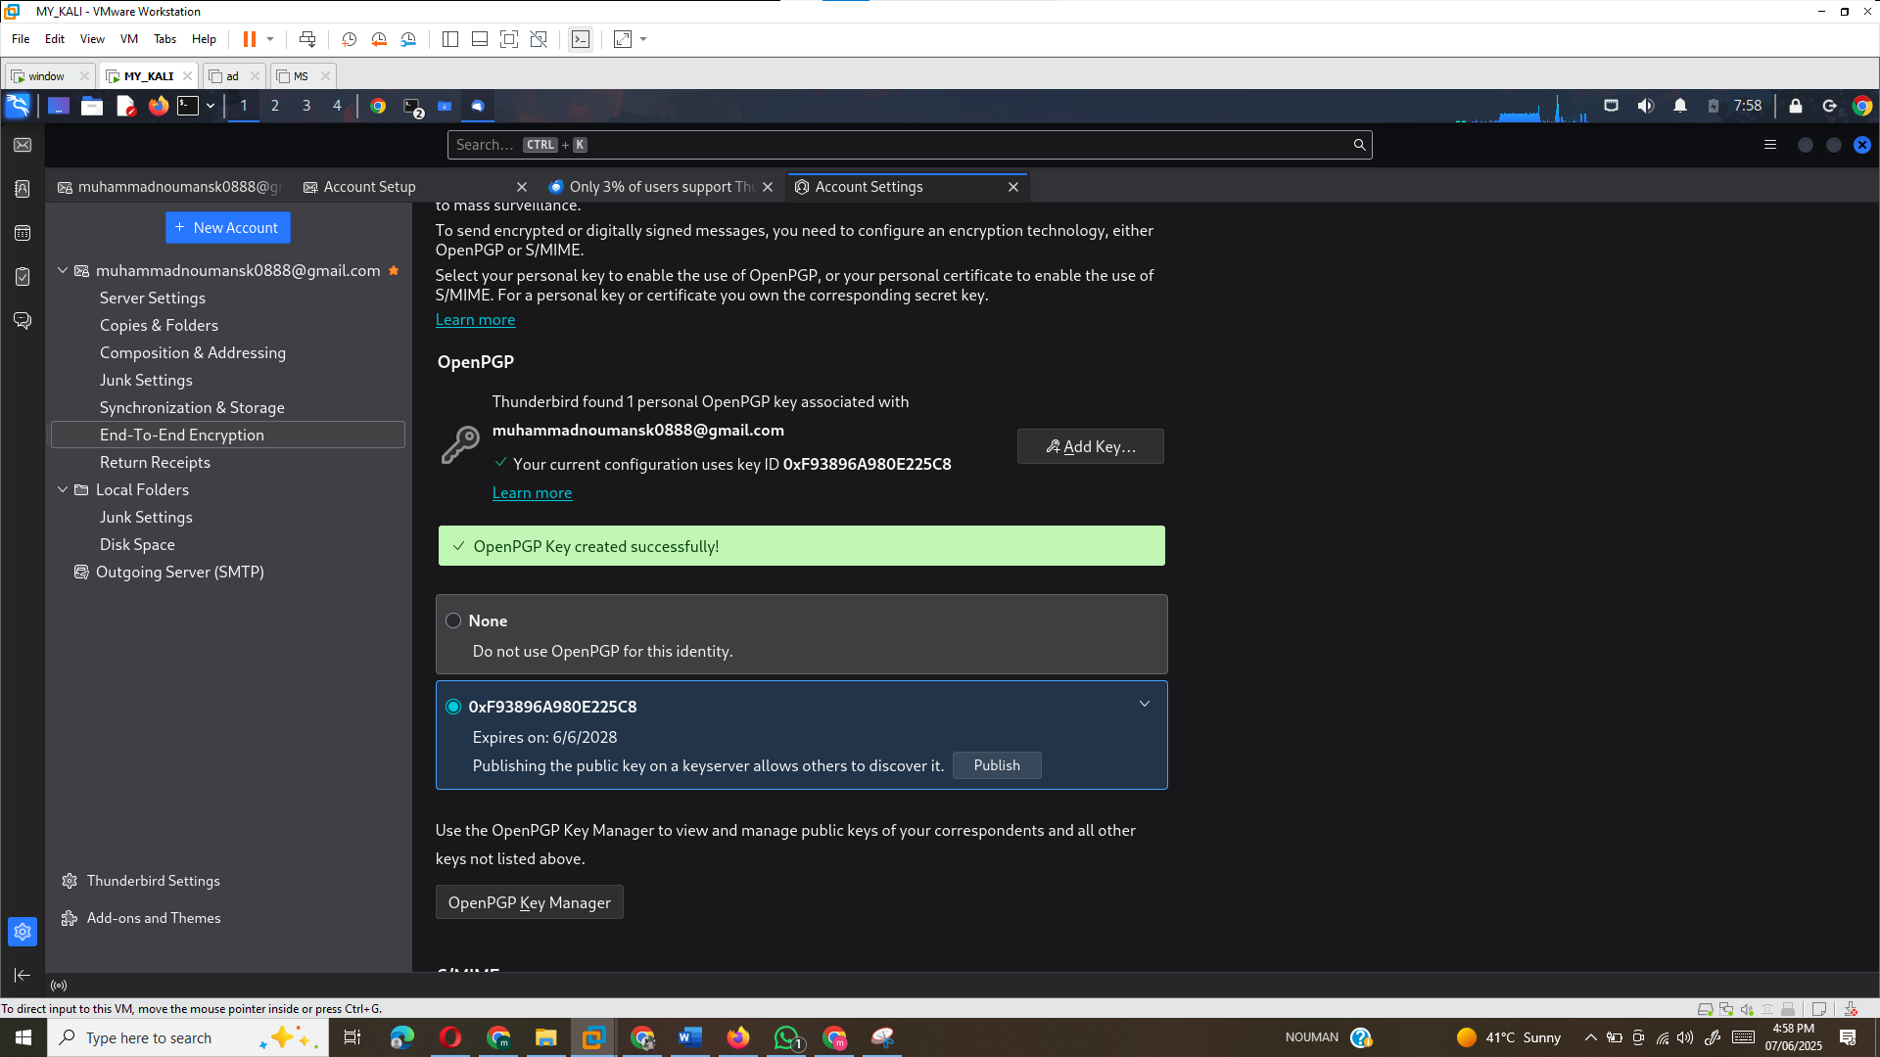
Step 4: Send an E-mail with Your Public Key
- Click on Write a New Email in Thunderbird.
- Write your message, then click the Security tab and select Encrypt and Digitally Sign.
- Send the email to your partner. Your public key will be attached, allowing them to encrypt a symmetric key and verify your digital signature.
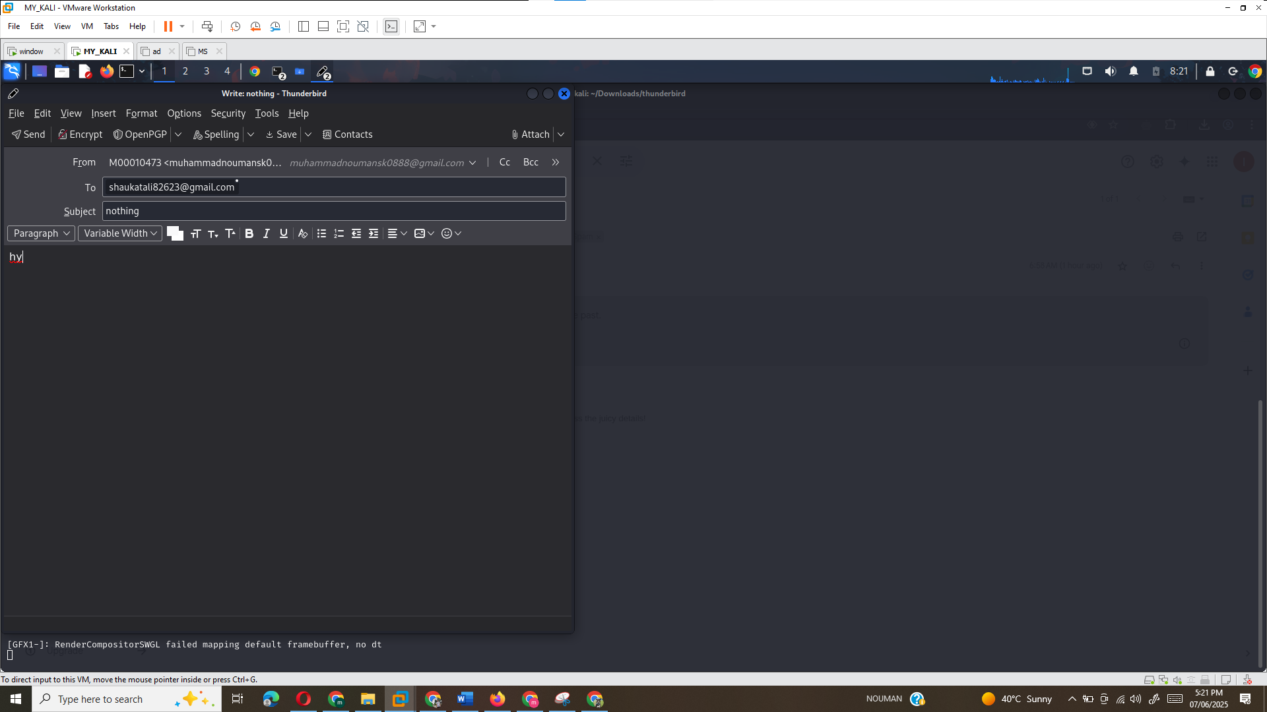
Step 5: Receive an Encrypted E-mail from Your Partner
- When your partner sends you an encrypted e-mail, open it in Thunderbird.
- Click on the OpenPGP button to check the digital signature. It should say "Good Digital Signature" and "Message Is Encrypted."
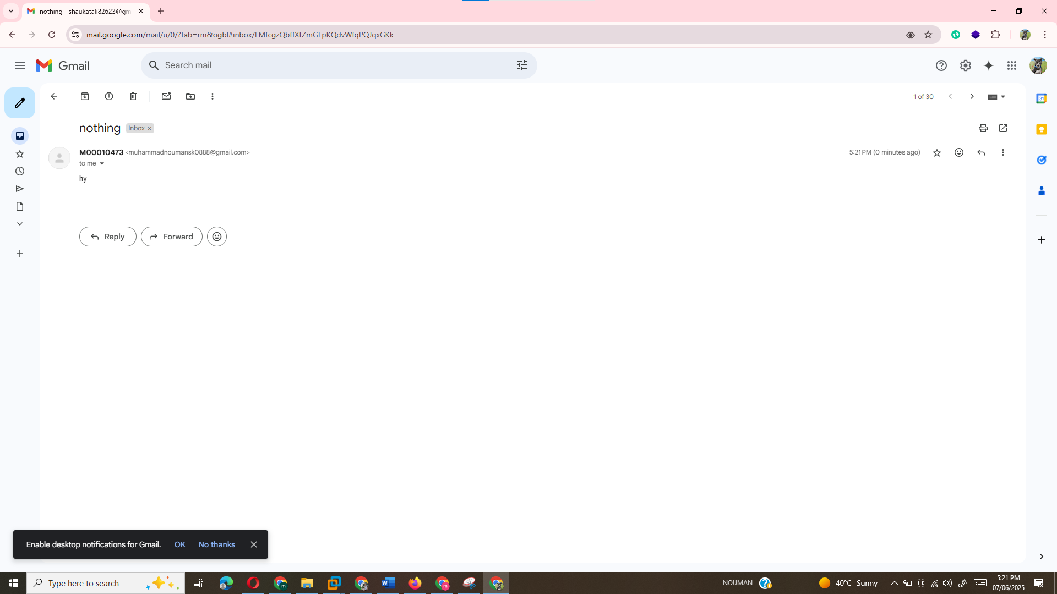

Reflection Questions:
Here are some answers to the reflection questions based on the steps you followed:
- How does the e-mail look in the web browser compared to how it looks in Thunderbird? Why is this the case?
  - In the web browser, the e-mail might appear as unreadable text with attachments because it is encrypted. In Thunderbird, the e-mail will be decrypted and readable because Thunderbird supports OpenPGP encryption.
- When you encrypted the e-mail to your partner, which key encrypted the e-mail?
  - Your partner’s public key encrypted the e-mail.
- When you encrypted the e-mail to your partner, which key encrypted the key that encrypted the e-mail?
  - Your private key encrypted the symmetric key used to encrypt the e-mail.
- When your partner decrypted that e-mail, which key decrypted the e-mail?
  - Your partner’s private key decrypted the e-mail.
- When your partner decrypted that e-mail, which key decrypted the key that decrypted the e-mail?
  - Your partner’s public key decrypted the symmetric key used for the e-mail decryption.
- Why did one key encrypt the e-mail and another key encrypt that key?
  - The e-mail is encrypted with the recipient’s public key to ensure confidentiality, and the symmetric key is encrypted with the sender’s private key to ensure that only the sender could encrypt it.
- When you signed your e-mail to your partner, which key did you use?
  - You used your private key to sign the e-mail.
- When your partner verified your signature, which key did they use?
  - Your partner used your public key to verify your signature.
- How was confidentiality accomplished?
  - Confidentiality was achieved by encrypting the e-mail with the recipient’s public key, which only they can decrypt with their private key.
- How was integrity accomplished?
  - Integrity was ensured by digitally signing the e-mail with your private key, ensuring that the content hasn’t been altered.
- How was nonrepudiation accomplished?
  - Nonrepudiation was accomplished by using your private key to sign the e-mail, proving that you were the sender and preventing you from denying the action.

References:
- Kearns, D., O'Gorman, J., & Aharoni, M. (2019). The Principles of Computer Security: CompTIA Security+ and Beyond (5th ed.). McGraw-Hill Education.
- Zimmermann, P. (1999). Why I Wrote PGP. Retrieved from https://www.philzimmermann.com/EN/essays/WhyIWrotePGP.html
- Stallings, W. (2019). Computer Security: Principles and Practice (6th ed.). Pearson.
- Miller, R. (2017). Hacking: The Art of Exploitation (2nd ed.). No Starch Press.

